DOCKER IMAGE

Step-1 :
Make a account on docker hub on the given link https://hub.docker.com/ and create a public repository.

Step-2:
If you are working on windows you have to access Linux terminal by putty application/ you can run directly by the Linux machine.

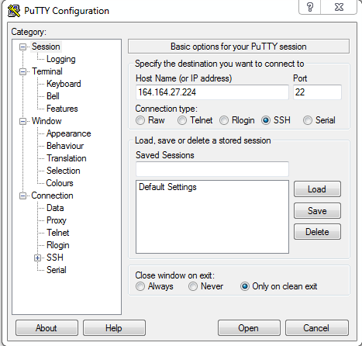

Step-3:
First you have to install docker by following commands on Linux terminal
- sudo yum -y update
- sudo yum install -y docker

Step-4:
Download apache-maven-3.6.0-bin.tar.gz binary archive from this official link: https://maven.apache.org/download.cgi .This article uses the Maven version 3.6.0. You need to replace the version number by whatever the version you are downloading.

Following commands for installing maven.

Open the Terminal and move to the /opt directory.
cd /opt

Extract the apache-maven archive into the opt directory.
sudo tar -xvzf ~/Downloads/apache-maven-3.6.1-bin.tar.gz

Edit the /etc/environment file and add the following environment variable:
M2_HOME="/opt/apache-maven-3.6.1"

also, append the bin directory to the PATH variable:
/opt/apache-maven-3.6.1/bin

You can use nano to edit the file in the terminal itself. Execute the following command and modify the content as given below.
sudo nano /etc/environment

WARNING: Do not replace your environment file with the following content because you may already have different environment variables which are required by other applications to function properly. Notice the end of PATH variable and the M2_HOME variable.
PATH="/usr/local/sbin:/usr/local/bin:/usr/sbin:/usr/bin:/sbin:/bin:/usr/games:/usr/local/games:/usr/lib/jvm/jdk-10.0.2/bin:/opt/apache-maven-3.6.1/bin"
JAVA_HOME="/usr/lib/jvm/jdk-10.0.2"
M2_HOME="/opt/apache-maven-3.6.1"
After the modification, press Ctrl + O to save the changes and then press ENTER key and then Ctrl + X to exit nano.

Update the mvn command:
sudo update-alternatives --install "/usr/bin/mvn" "mvn" "/opt/apache-maven-3.6.1/bin/mvn" 0
sudo update-alternatives --set mvn /opt/apache-maven-3.6.1/bin/mvn

Logout and login to the computer and check the Maven version using the following command.
mvn --version

Note: You can also visit the site : https://www.javahelps.com/2017/10/install-apache-maven-on-linux.html

Step-5:
Download the latest JDK(jdk-8u201-linux-x64.tar.gz) from this official site.
https://www.oracle.com/technetwork/java/javase/downloads/jdk8-downloads-2133151.html
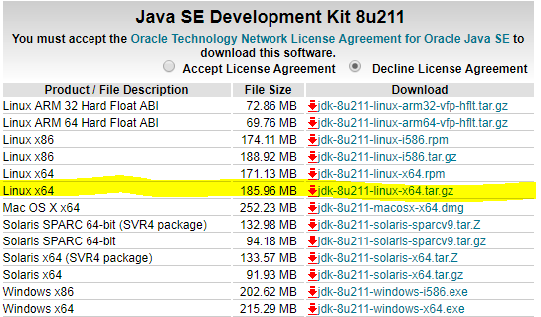

Open the terminal (Ctrl + Alt + T) and enter the following command.
sudo mkdir /usr/lib/jvm
If the /usr/lib/jvm folder does not exist, this command will create the directory. If you already have this folder, you can ignore this step and move to next step.

Enter the following command to change the directory.
cd /usr/lib/jvm

Extract the jdk-8u201-linux-x64.tar.gz file in that directory using this command.
sudo tar -xvzf ~/Downloads/jdk-8u211-linux-x64.tar.gz
According to this command, the JDK filename is jdk-8u201-linux-x64.tar.gz and which is located in the ~/Downloads folder. If your downloaded file is in any other location, change the command according to your path.

Enter the following command to open the environment variables file.
sudo nano /etc/environment

In the opened file, add the following bin folders to the existing PATH variable.
/usr/lib/jvm/jdk1.8.0_201/bin
/usr/lib/jvm/jdk1.8.0_201/db/bin
/usr/lib/jvm/jdk1.8.0_201/jre/bin

The PATH variables have to be separated by semicolon.
Notice that the installed JDK version is 1.8 update 201. Depending on your JDK version, the paths can be different.
Add the following environment variables at the end of the file.
J2SDKDIR="/usr/lib/jvm/jdk1.8.0_211"
J2REDIR="/usr/lib/jvm/jdk1.8.0_211/jre"
JAVA_HOME="/usr/lib/jvm/jdk1.8.0_211"
DERBY_HOME="/usr/lib/jvm/jdk1.8.0_211/db"
The environment file before the modification:
PATH="/usr/local/sbin:/usr/local/bin:/usr/sbin:/usr/bin:/sbin:/bin:/usr/games:/usr/local/games:/usr/lib/jvm/jdk1.8.0_211/bin:/usr/lib/jvm/jdk1.8.0_211/db/bin:/usr/lib/jvm/jdk1.8.0_211/jre/bin"
J2SDKDIR="/usr/lib/jvm/jdk1.8.0_211"
J2REDIR="/usr/lib/jvm/jdk1.8.0_211/jre"
JAVA_HOME="/usr/lib/jvm/jdk1.8.0_211"
DERBY_HOME="/usr/lib/jvm/jdk1.8.0_211/db"

Save the changes and close the nano.

Enter the following commands to inform the Ubuntu about the Java's location. Depending on your JDK version, the paths can be different.
sudo update-alternatives --install "/usr/bin/java" "java" "/usr/lib/jvm/jdk1.8.0_211/bin/java" 0

sudo update-alternatives --install "/usr/bin/javac" "javac" "/usr/lib/jvm/jdk1.8.0_211/bin/javac" 0

sudo update-alternatives --set java /usr/lib/jvm/jdk1.8.0_211/bin/java

sudo update-alternatives --set javac /usr/lib/jvm/jdk1.8.0_211/bin/javac
To verify the setup enter the following commands and make sure that they print the location of java and javac as you have provided in the previous step.

update-alternatives --list java

update-alternatives --list javac
Restart the computer (or just log-out and login) and open the terminal again.

Enter the following command.
java -version
If you get the installed Java version as the output, you have successfully installed the Oracle JDK in your system.

After configuration of all these things you have to do some changes in your spring boot application.
First create a docker file
Ex.
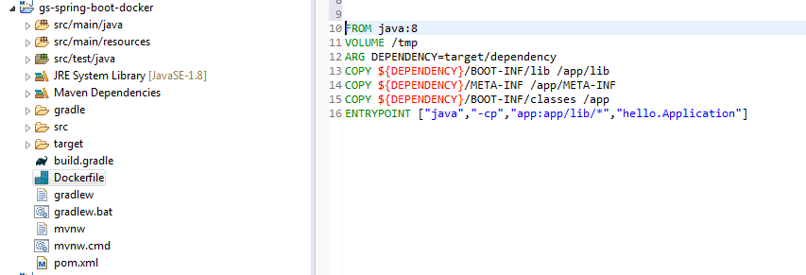

Code:
FROM java:8
VOLUME /tmp
ARG DEPENDENCY=target/dependency
COPY ${DEPENDENCY}/BOOT-INF/lib /app/lib
COPY ${DEPENDENCY}/META-INF /app/META-INF
COPY ${DEPENDENCY}/BOOT-INF/classes /app
EXPOSE 8080
ENTRYPOINT ["java","-cp","app:app/lib/*","hello.Application"]

Add docker dependency in pom file:
<?xml version="1.0" encoding="UTF-8"?>
<project xmlns="http://maven.apache.org/POM/4.0.0"
xmlns:xsi="http://www.w3.org/2001/XMLSchema-instance"
xsi:schemaLocation="http://maven.apache.org/POM/4.0.0 https://maven.apache.org/xsd/maven-4.0.0.xsd">
<modelVersion> 4.0.0</modelVersion>
<groupId>org.springframework</groupId>
<artifactId>spring-boot-docker-test</artifactId>
<version>0.1.0</version>
<packaging>jar</packaging>
<name>Spring Boot Docker</name>

<description>Getting started with Spring Boot and Docker</description>
<parent>
<groupId>org.springframework.boot</groupId>
<artifactId>spring-boot-starter-parent</artifactId>
<version>2.1.4.RELEASE</version>
<relativePath />
</parent>
<properties>
<docker.image.prefix>shyamj007 </docker.image.prefix>
<java.version>1.8</java.version>
</properties>
<build>
<extensions></extensions>
<plugins>
<plugin>
<groupId>org.springframework.boot</groupId>
<artifactId>spring-boot-maven-plugin</artifactId>
</plugin>
<!-- tag::plugin[] -->
<plugin>
<groupId>com.spotify</groupId>
<artifactId>dockerfile-maven-plugin</artifactId>
<version>1.4.9</version>
<configuration>
<repository>
${docker.image.prefix}/springio-spring-boot-docker-test
</repository>
<!-- <to> <image> ${docker-registry}/${project.artifactId} </image> </to> -->
</configuration>
</plugin>
<!-- end::plugin[] -->
<!-- tag::unpack[] -->
<plugin>
<groupId>org.apache.maven.plugins</groupId>
<artifactId>maven-dependency-plugin</artifactId>
<executions>
<execution>
<id>unpack</id>
<phase>package</phase>
<goals>
<goal>unpack</goal>
</goals>
<configuration>
<artifactItems>
<artifactItem>
<groupId>${project.groupId}</groupId>
<artifactId>${project.artifactId}</artifactId>
<version>${project.version}</version>
</artifactItem>
</artifactItems>
</configuration>
</execution>
</executions>
</plugin>
<!-- end::unpack[] -->
</plugins>
</build>
<dependencies>
<dependency>
<groupId>org.springframework.boot</groupId>
<artifactId>spring-boot-starter-web</artifactId>
</dependency>
<dependency>
<groupId>org.springframework.boot</groupId>
<artifactId>spring-boot-starter-test</artifactId>
<scope>test</scope>
</dependency>
</dependencies>
</project>

Step-6:
Now move into your project folder where your docker file exists through the cd command and and login in drocker using docker login command
docker login

Then execute docker image build command.
sudo mvn clean package dockerfile:build
It will create docker image of a project

Step-7:
Write docker push command For push the docker image in docker repository
docker push shyamj007/springio-spring-boot-docker-test:latest
Now check the docker image in your docker hub repository

Step-8:
Write docker pull command for pull the docker image in your terminal.
docker pull shyamj007/springio-spring-boot-docker-test

Step-9:
For host the docker image on your local machine
sudo docker run shyamj007/springio-spring-boot-docker-test

Step 10:

sudo docker run -d -p 8080:8080shyamj007/springio-spring-boot-docker-test:latest
( use docker image name)

You can also use “docker curl http://localhost:8080” command to execute code on the terminal.

For execute docker image visit here:
https://stackify.com/guide-docker-java/

